The Rhyme Game

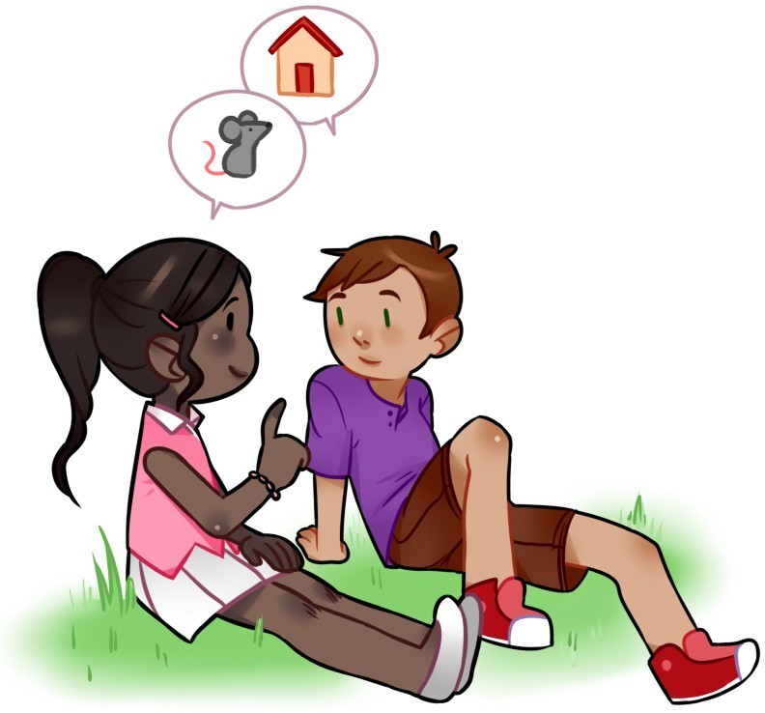Bella and James sat on the grass. “Let’s play the rhyme game,” Bella said. “First, you say a word. Then, I’ll say a word that rhymes.” James nodded. “Truck,” he said. “Duck,” Bella rhymed.

“House,” James said. “Mouse,” Bella rhymed.

“Dog,” James said. “Frog,” Bella rhymed.

“Can I do the rhyming now?” James asked. “Yes,” Bella said. “Dress,” James rhymed. Bella laughed. “Wait. Yes wasn’t my word. Here it is now.”

“Cow,” James rhymed. “No,” Bella said, laughing harder. “No, no, no.”

“Go,” James rhymed. “Go, go, go.”

Bella laughed so hard she rolled on the grass.

James rolled next to her. Rhyming was fun!